Exam GR8677 Problems 11-20

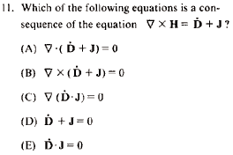

A----is the answer. Divergence of Curl is zero. Done.

---------------------------------------------------------------------

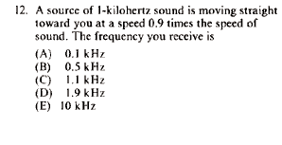

The frequency will be higher than 1kHz.

Doppler for source moving toward (o is for observer)

f_{O} = f_{S}/(1 − v_{S}/c)---so 10 times as big since going 90% the speed of wave.
Answer E

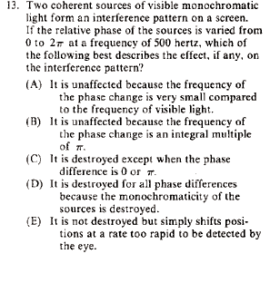

E----the pattern shift ---the full cycle of phase is like “adding “ one wavelength of path difference.

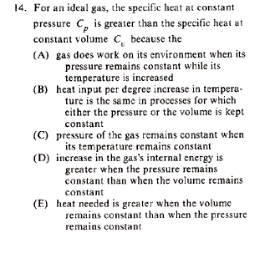

A----read A----done. Work is needed in addition to raising temp, since volume is increasing. You need to add energy to not only increase temp, but also to have gas increase its volume against---whatever---as needed to keep the pressure constant. At constant volume pressure would increase, but no work done since no displacement.

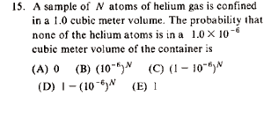

I’m good with the web site answer

Probability is mostly common sense and adhering to definitions.
The probability that a gas molecule or atom is in the small cube is . The probability that it's not in that small cube is . Assuming independent gas molecules or atoms, i.e., the usual assumption of randomness in Stat Mech, one gets, .
The answer is thus C.

Note the result must be small---for a number like 0.999999 raised to a number like 10^23, you will get a small probability. However if there are only two particles in this box then it is not very likely to find one in a 1cc region.

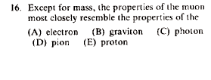

A muon has charge -1 and spin 1/2.
An electron has charge -1 and spin 1/2.

You need to just know this one---it is a ---do I know properties of nuclear particles---memorization. Know it or skip it.

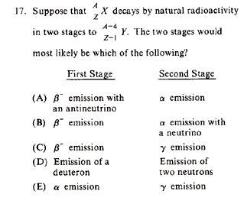

A adds up.

So does B, but beta emission occurs with anti neutrino.

C does not add up.

Deuteron (n+p) are not a stable particle, more likely to have alpha happen in second stage in a.

E does not add up.

Answer A

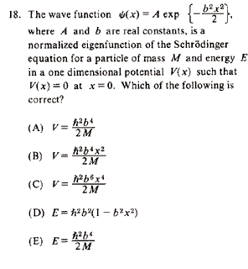

The wave function is harm osc ground state. Answer B!!!!!!!!!!!!
You can plug into S.E. ---Time indep. Take derivatives of Gaussian, and it will pull out the x squared. ---D can not be correct since Energy cannot vary with x. A can’t be correct since potential is constant. E does not have dimensions of energy. You can’t get C since derivative in S.E won’t work out to x^4.

Best just to know Harm. Osc.

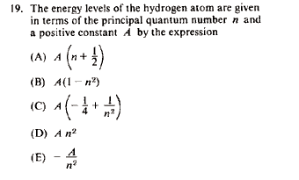

Energy =-13.6eV/n² and you better just know this.

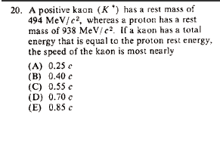

So you get gamma is about 2 and ---solve for beta^2 =3/4. Take sqrt to get known 0.866. Answer E

